IAM

1. Create one IAM user and assign ec2,s3 full access role.

**IAM 🡪 user 🡪 create user**

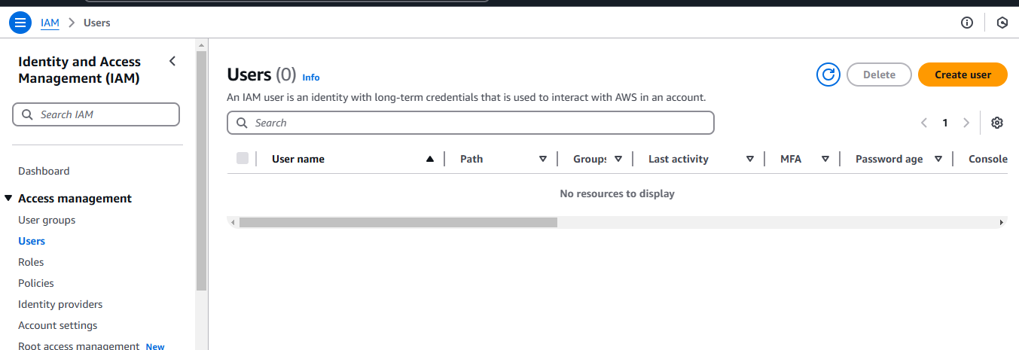

**Give add user to group or attached policy**

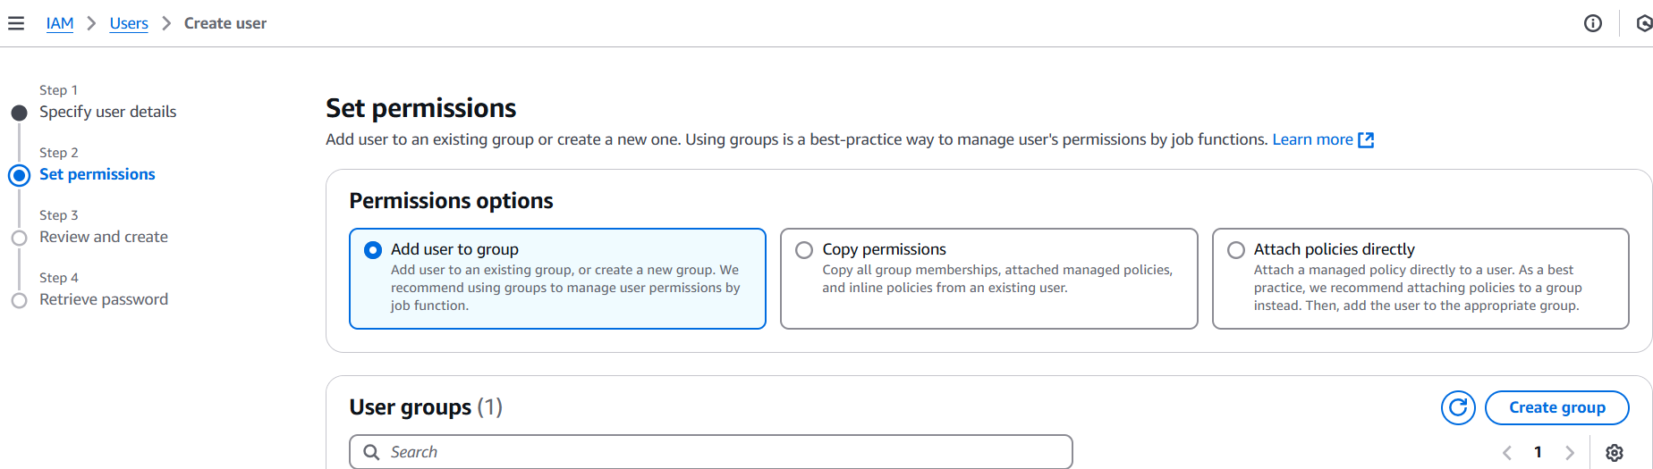

Go to policy and give full permissions to user

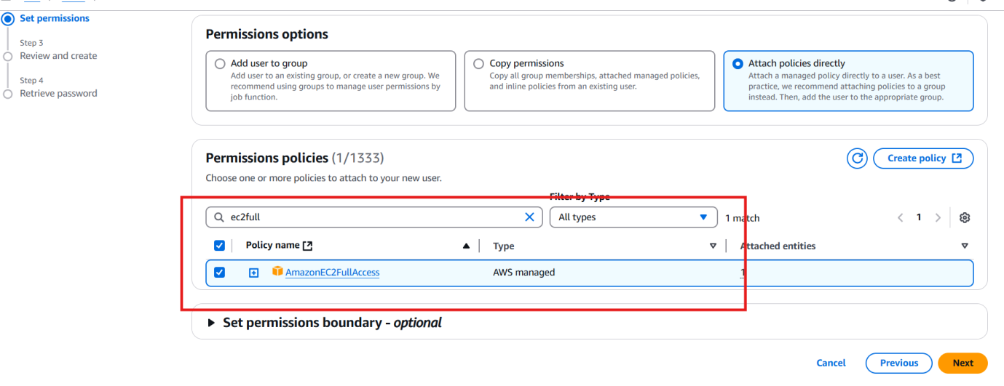

Given full permission to EC2 and S3

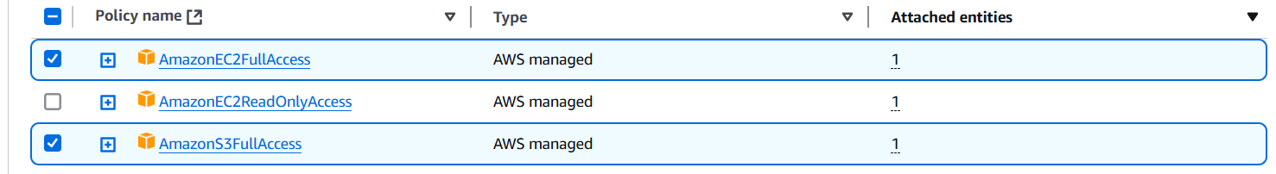

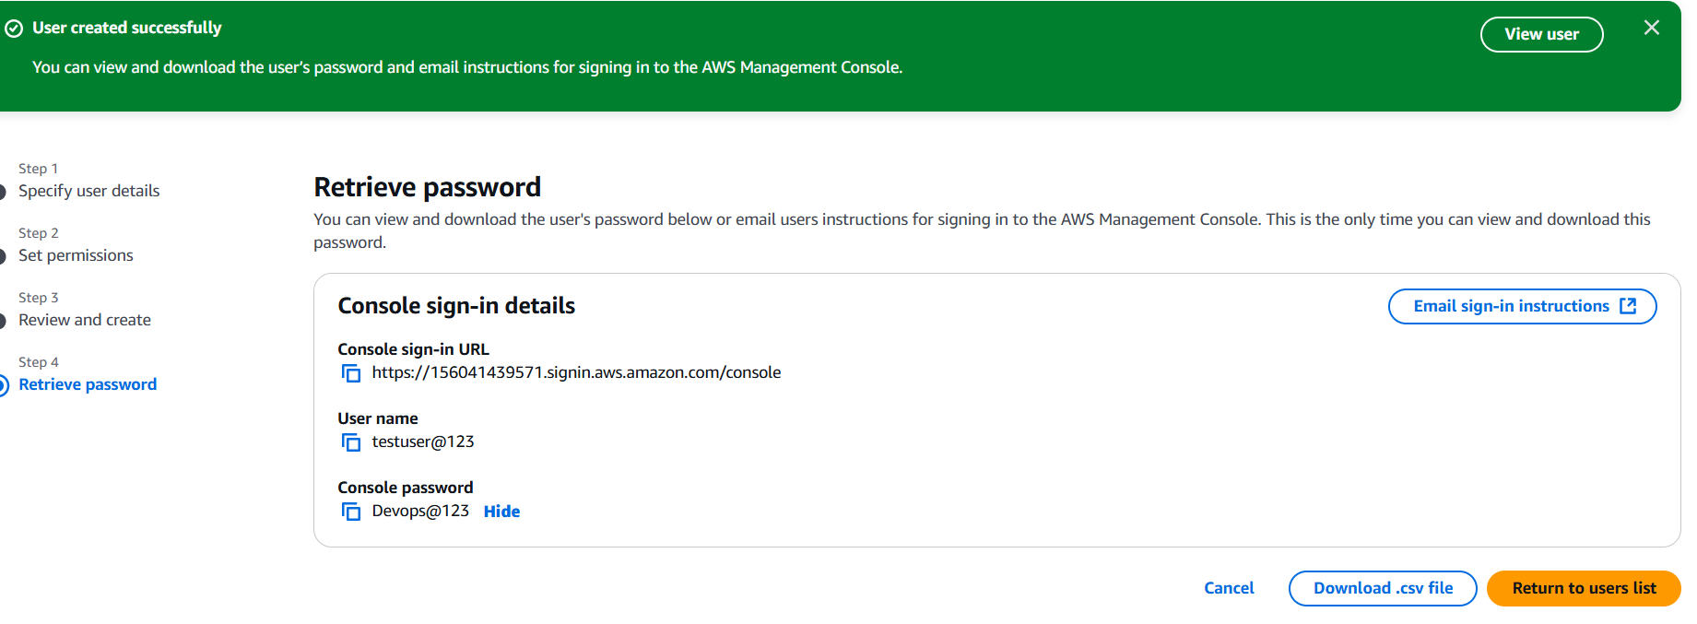

1. Create one Group in IAM and Assign Read access for ec2

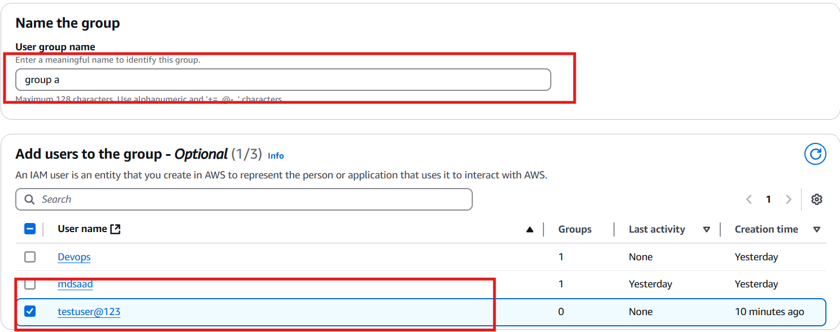

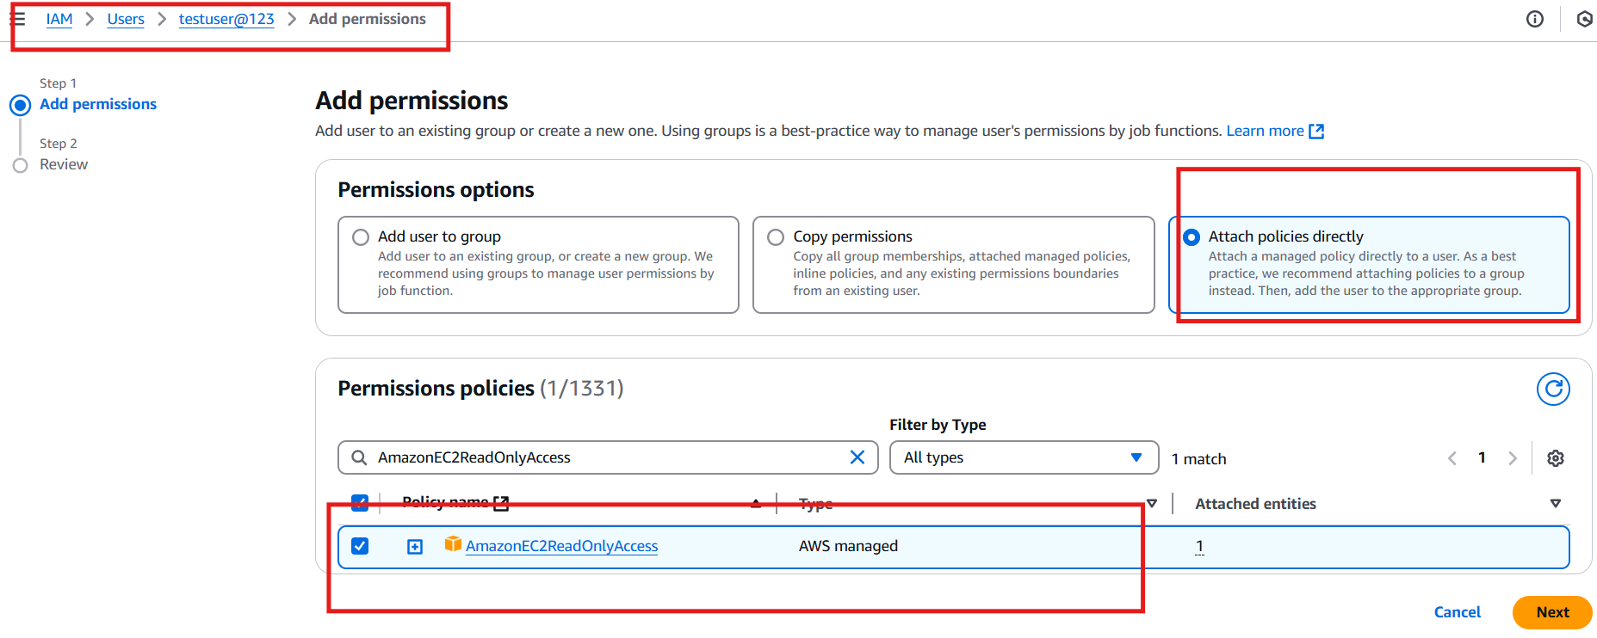

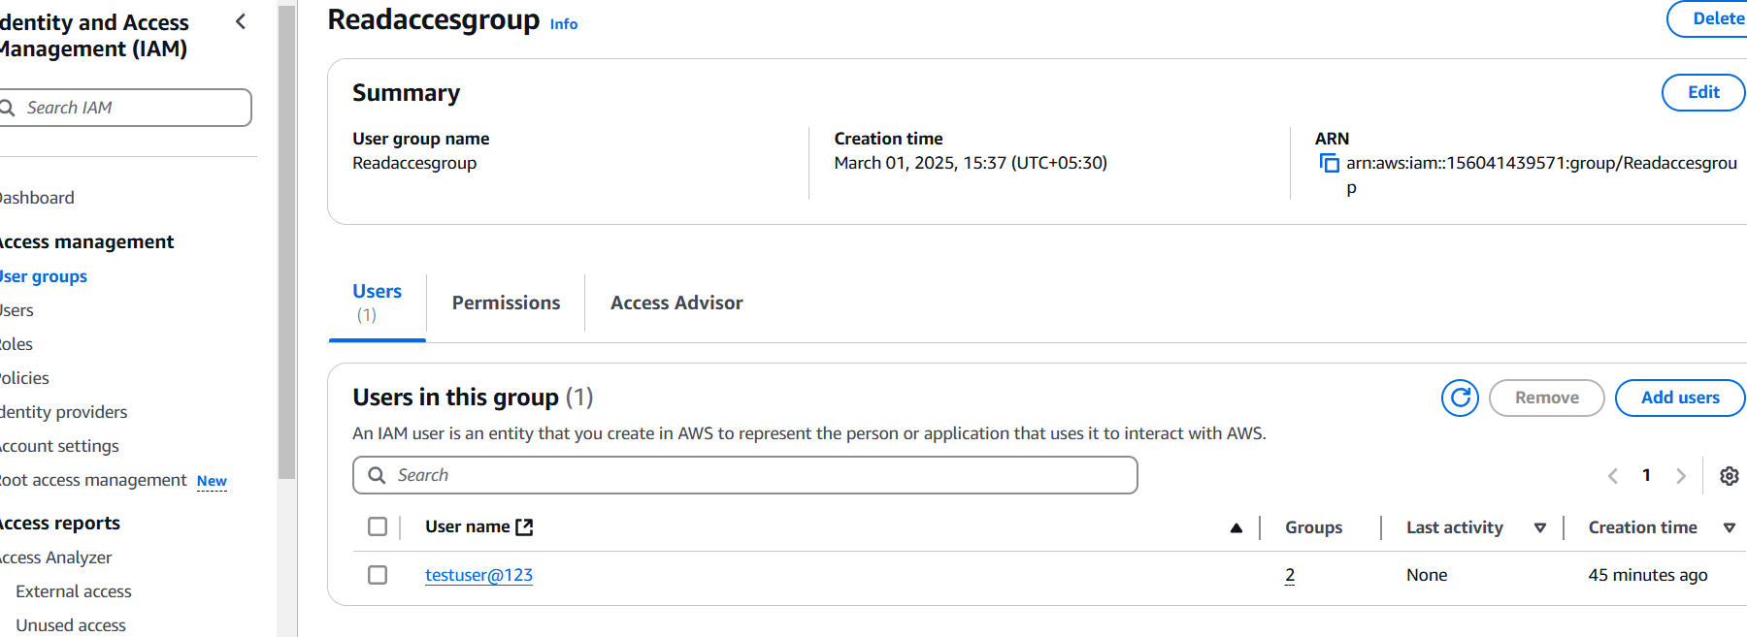

1. Create a new user with name DevopsOperation and add to the group created in task2.

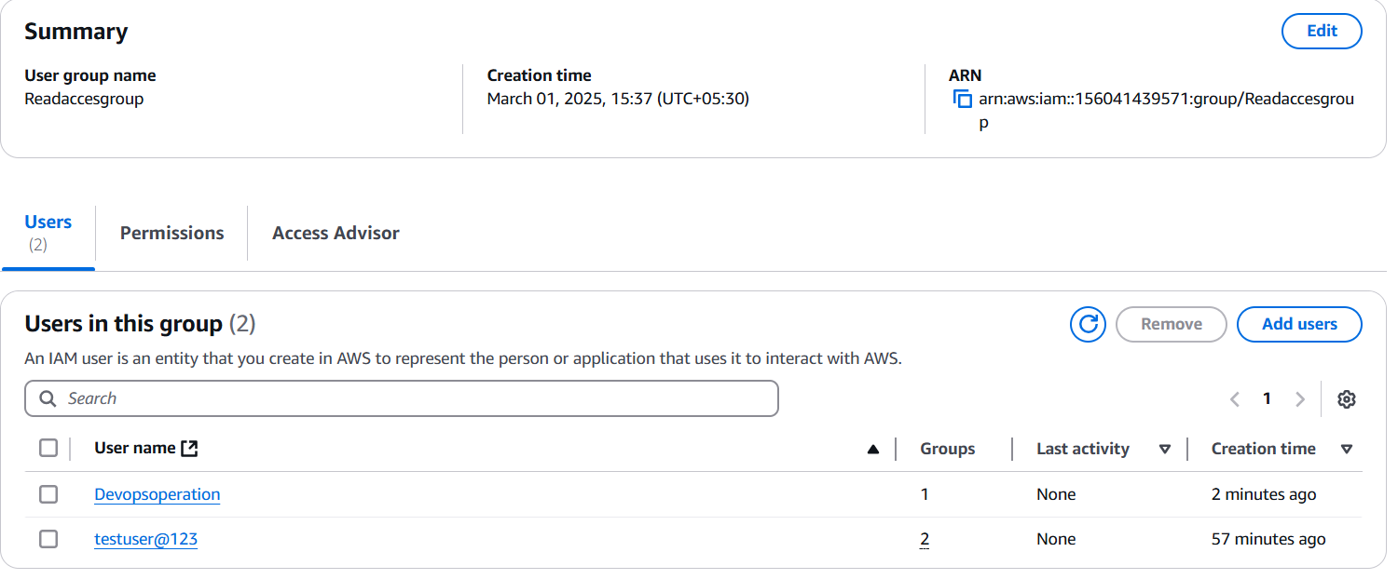

1. Write a bash script to create a IAM user with VPC full access.

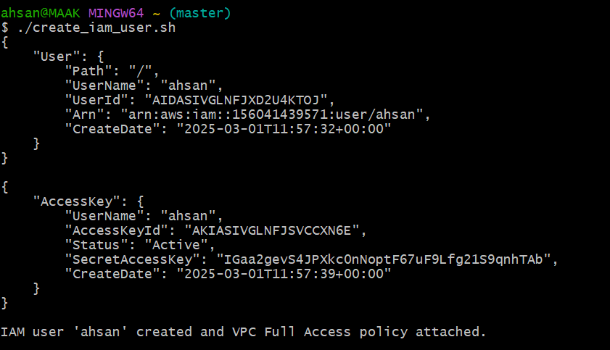

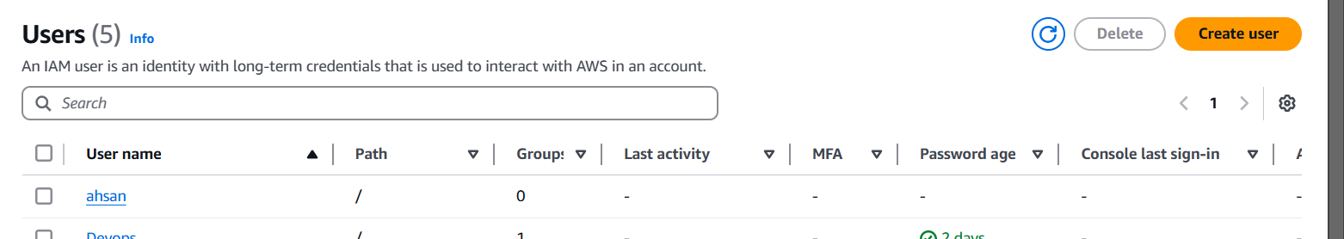

5 Create a IAM policy to access ec2 for a specific user in specific regions only.)

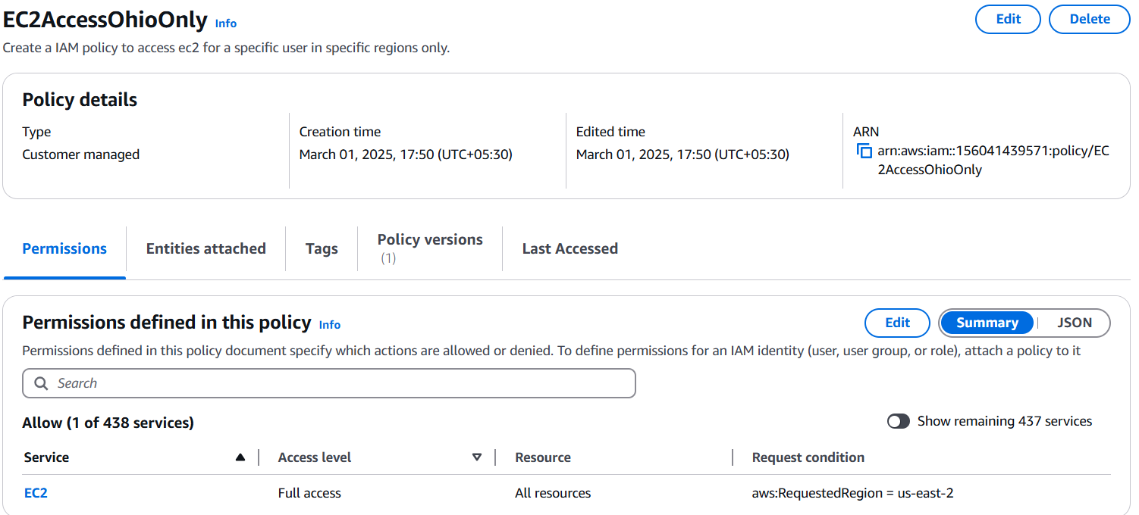

6) We have two accounts Account A and Account B, Account A user should access s3 bucket in Account B.

6